|  |
| --- |
| C:\Users\Priso\Downloads\Logo.jpg  C:\Users\Priso\AppData\Local\Microsoft\Windows\INetCache\Content.Word\BISCAM NAME.JPG |





**BISCAM CLEANING AGENCY**

**BISCAM CLEANING AGENCY**

**Keeping it clean always**

**ABOUT US**

BISCAM Cleaning Services is a branch of the BISCAM INVESTMENT GROUP with an eco-friendly perspective. We are dedicated to providing professional services at the best prices to all our clients. Our motto is “*KEEPING IT CLEAN ALWAYS*”.

**OUR SERVICES**

Our services range from residential through commercial to industrial cleaning; from housecleaning, janitorial work, to specialty cleaning. We clean like it’s our own home or office. We offer services in the following domains:

* General house cleaning
* Hotels and office cleaning
* Warehouse cleaning
* Ship deck cleaning
* Placement of workers for cleaning of Homes and Offices

**CALL US**

With a consistently and efficiently active customer service, we are dedicated to render the most qualitative services to all our clients, for their satisfaction. Our customer service is seriously committed to continuously build good relationships with our clients. We are just one call away. If it is dirty, then we can make it clean.

BISCAM INVESTMENT SARL

Ancienne route bonaberi, douala

p.o box 1159 douala

Telephone: (+237) 683079785

Mobile: (+237) 677941547

e-mail:



OUR SERVICES

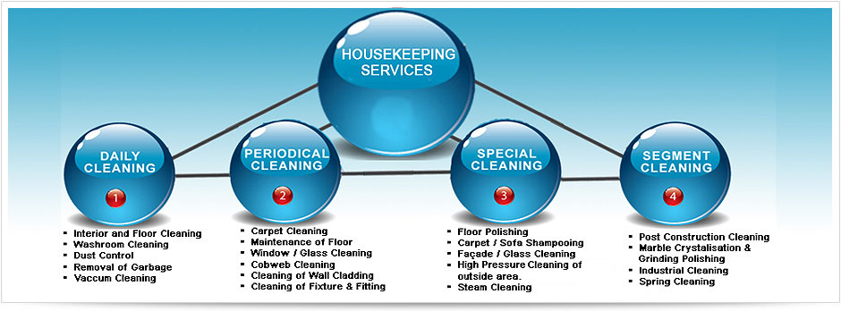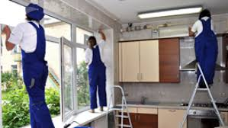

**Residential and Hotel cleaning**

**Eco-friendly cleaning materials**

**Washroom cleaning materials**



**Professional cleaners**



-interior & floor cleaning

-washroom cleaning

-dust control

-removal of garbage

-vacuum cleaning

**BISCAM CLEANING AGENCY**

**Keeping it clean always**

OUR SERVICE

HOUSE KEEPING SERVICES

1. DAIRLY CLEANING

-Interior and floor cleaning

-washroom cleaning

-Dust control

-Removal of garage

-Vacuum cleaning

2. PERIODICAL CLEANING

-carpet cleaning

-Maintenance of floor

-Windows/glass cleaning

Cobweb cleaning

-Cleaning of wall clothing

-Cleaning of pictures and painting

3. SPECIAL CLEANING

-Floor polishing

-Carpet and sofa shampooing

-Façade and glass cleaning

-High pressure cleaning

Of outside areas

-steam cleaning

4. SEGMENT CLEANING

-Post construction cleaning

-Marble crystallizations and grinding polishing

-Industrial cleaning

-Spring cleaning